东莞市拓取智能装备有限公司
Dongguan Tuoqu Intelligent Equipment Co., Ltd.

光纤激光打标机操作说明书
Fiber Laser Marking Machine Operation Manual

中英文对照版 / Chinese-English Bilingual Edition

版本 / Version: V1.0
日期 / Date: 2026-06
文件编号 / Document No.: TQ-OM-001

目 录 / Table of Contents

第一章 安全须知 / Safety Instructions
第二章 设备概述 / Equipment Overview
第三章 开机与关机操作规程 / Power On/Off Procedures
第四章 设备日常保养 / Daily Equipment Maintenance
第五章 EzCad2 软件操作说明 / EzCad2 Software Operation
5.1 软件启动与界面介绍 / Software Startup & Interface
5.2 文件操作 / File Operations
5.3 绘制与编辑 / Drawing & Editing
5.4 加工设置与运行 / Processing Setup & Execution
5.5 设备参数设置 / Device Parameter Settings
第六章 操作人员操作规程 / Operator Procedures
第七章 常见故障排除 / Troubleshooting
第八章 联系方式 / Contact Information

第一章 安全须知
Chapter 1 Safety Instructions
⚠ 激光安全警告 / Laser Safety Warning
⚠ LASER SAFETY WARNING
本设备使用四类激光器（强激光辐射），激光辐射可能引起以下事故：
This equipment uses a Class 4 laser (high-power laser radiation). Laser radiation may cause the following accidents:
1. 点燃聚焦镜附近的易燃物品；
1. Ignition of flammable items near the focusing lens;
2. 激光加工过程中，因加工对象不同可能产生辐射及有毒、有害气体；
2. During laser processing, radiation and toxic/harmful gases may be generated depending on the workpiece material;
3. "激光辐射"直接照射会引起人体伤害。
3. Direct exposure to "laser radiation" can cause bodily injury.
设备使用场所必须配备消防器材，严禁在工作台及设备周围堆放易燃、易爆物品。
Fire-fighting equipment must be provided at the equipment site. Flammable and explosive items are strictly prohibited on the workbench and around the equipment.

1.1 电气安全
Electrical Safety
• 打标机及所有相关设备必须安全接地，接地电阻不大于0.5Ω，方可开机操作。
• The marking machine and all related equipment must be safely grounded with grounding resistance <=0.5 ohm before power-on.
• 严禁在设备工作区域内放置任何具有全反射或漫反射的物体，以防激光反射到人体或易燃物品。
• Never place any fully reflective or diffusely reflective objects within the equipment work area to prevent laser reflection onto the human body or flammable items.
• 设备工作电压：AC220V，50Hz；总功率<1000W。当电网电压不稳定或不匹配时，严禁开机。
• Operating voltage: AC220V, 50Hz; Total power <1000W. Never power on when grid voltage is unstable or mismatched.
• 出现异常现象时，首先关闭激光电源和振镜电源，再行检查。
• In case of abnormal phenomena, first turn off the laser power and galvanometer power before inspection.
1.2 环境与电磁安全
Environment & EMC Safety
• 设备所处环境应干燥、无污染、无振动、无强电、强磁等干扰。
• The equipment environment shall be dry, pollution-free, vibration-free, and free from strong electrical/magnetic interference.
• 设备应远离对电磁干扰敏感的电气设备，设备本身也可能产生电磁干扰。
• Keep the equipment away from electrical devices sensitive to electromagnetic interference; the equipment itself may also generate EMI.
• 不要在振镜头附近拨打或接听手机、对讲机等具有高强度电磁波辐射的设备。
• Do not make or receive mobile phone calls or use walkie-talkies near the galvanometer head due to high-intensity electromagnetic radiation.
• 工作环境温度：5~40°C；工作环境湿度：5%~95%（无冷凝）。
• Operating environment temperature: 5~40°C; humidity: 5%~95% (non-condensing).
1.3 光纤与光学安全
Fiber & Optical Safety
• 严禁弯折光纤（光纤为玻璃纤维），如需弯曲，保证光纤弯曲最小圆直径大于20厘米。
• Never bend the optical fiber (glass fiber). If bending is necessary, ensure the minimum bending diameter is >20cm.
• 操作人员必须佩戴防护眼镜（建议OD>=5，波长对应1064nm）。
• Operators must wear protective laser safety glasses (recommended OD>=5, wavelength matched to 1064nm).
• 若发现聚焦镜头上有油脂，须取下镜头，用棉签蘸99.5%以上纯酒精擦洗，否则影响打标效果。
• If grease is found on the focusing lens, remove the lens and clean with a cotton swab dipped in >=99.5% pure alcohol. Failure to do so affects marking quality.
• 检查场镜盖子是否盖在镜头上面，若盖着必须取下，避免激光烧坏镜盖。
• Check whether the field lens cover is on the lens. If yes, remove it to prevent laser from burning the cover.
1.4 人员资质要求
Personnel Qualification
• 操作人员须具备一定的电器基础和计算机基础，未经培训人员禁止操作设备。
• Operators must have basic electrical and computer knowledge. Untrained personnel are prohibited from operating the equipment.
• 非专业操作人员禁止接近该设备。
• Non-professional operators are prohibited from approaching the equipment.
• 操作人员须戴上防护手套。
• Operators must wear protective gloves during operation.

第二章 设备概述
Chapter 2 Equipment Overview
本操作说明书适用于东莞市拓取智能装备有限公司生产的光纤激光打标机系列设备。
光纤激光打标机是利用光纤激光器输出激光，通过光学扫描系统（振镜）偏转，经场镜聚焦后在工件表面进行标记加工的自动化设备。
This operation manual applies to the Fiber Laser Marking Machine series equipment produced by Dongguan Tuoqu Intelligent Equipment Co., Ltd.
The Fiber Laser Marking Machine uses a fiber laser to output laser beams, which are deflected by an optical scanning system (galvanometer) and focused by a field lens to mark the workpiece surface.
2.1 设备外观与结构
Equipment Appearance & Structure
下图展示了光纤激光打标机的主要组成部分：
The figure below shows the main components of the fiber laser marking machine:
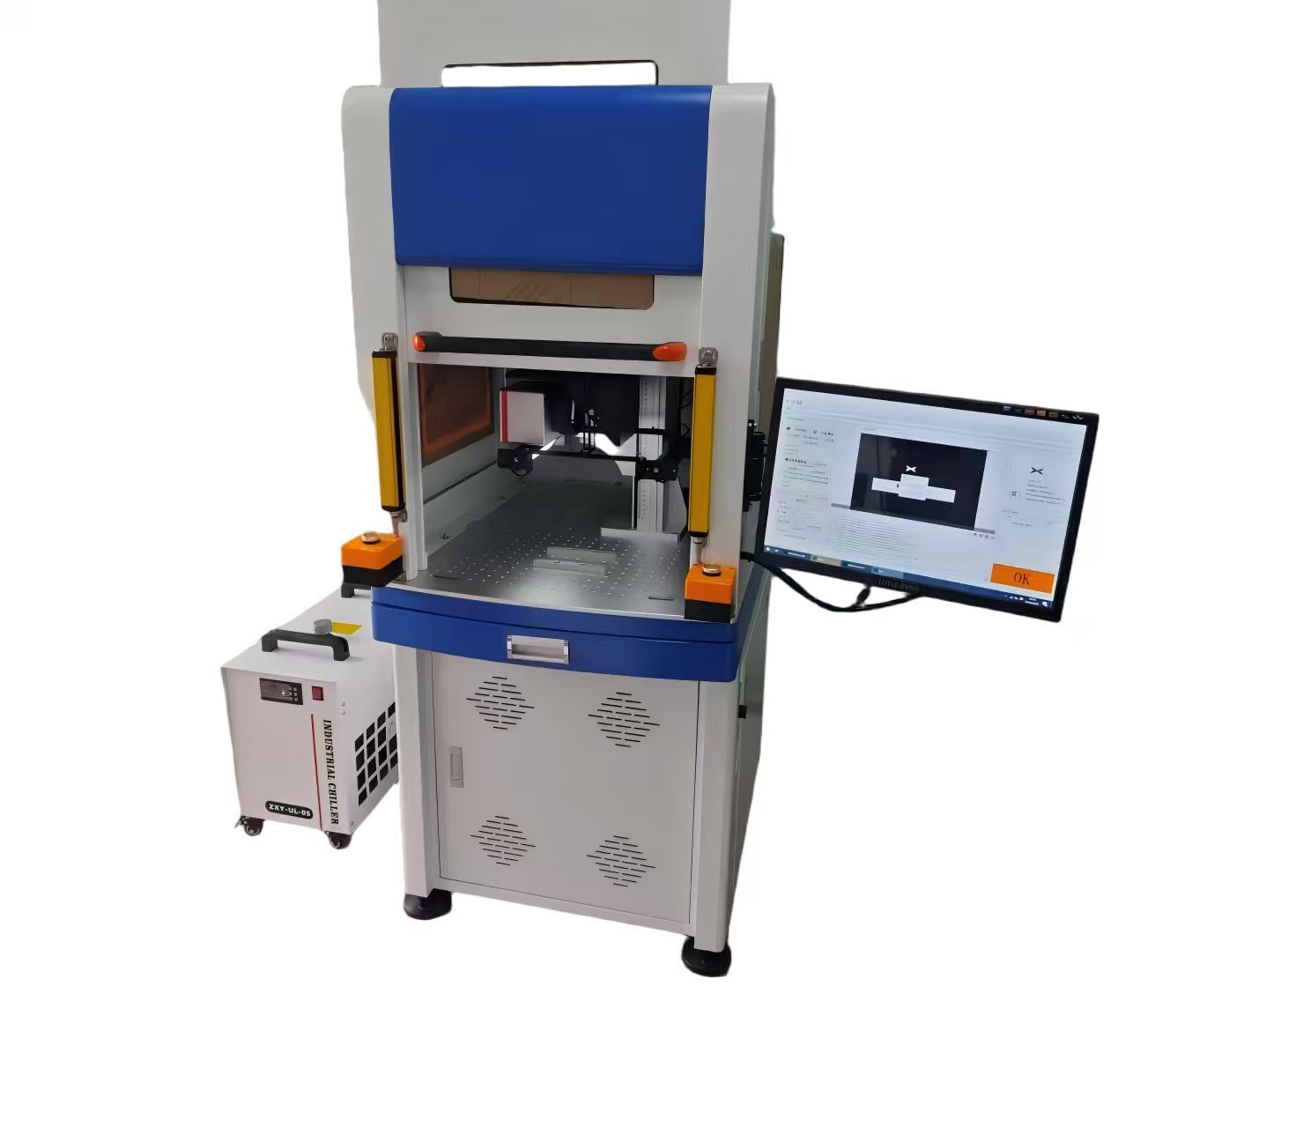

编号  No. | 部件名称  Component Name | 功能说明  Function Description
1 | ① 激光头 / Laser Head | 设备核心部件，发射1064nm激光束进行打标加工
2 | ② 安全光栅 / Safety Light Curtain | 防护装置，检测人员进入打标区域时自动停止激光
3 | ③ 显示器 / Display Monitor | 运行EzCad2软件，显示打标界面和参数设置
4 | ④ 防护罩 / Protective Enclosure | 全封闭防护，防止激光外泄和烟尘扩散
5 | ⑤ 工作台 / Workbench | 放置待加工工件，可X/Y方向调节
6 | ⑥ 控制电箱 / Control Cabinet | 内置激光电源、振镜驱动、控制电路等
7 | ⑦ 工业冷水机 / Industrial Chiller | 为激光器提供恒温冷却，确保稳定运行

2.2 设备尺寸图
Equipment Dimension Drawing
下图为本设备的外形尺寸图，供安装布置参考：
The figure below shows the equipment outline dimension drawing for installation reference:
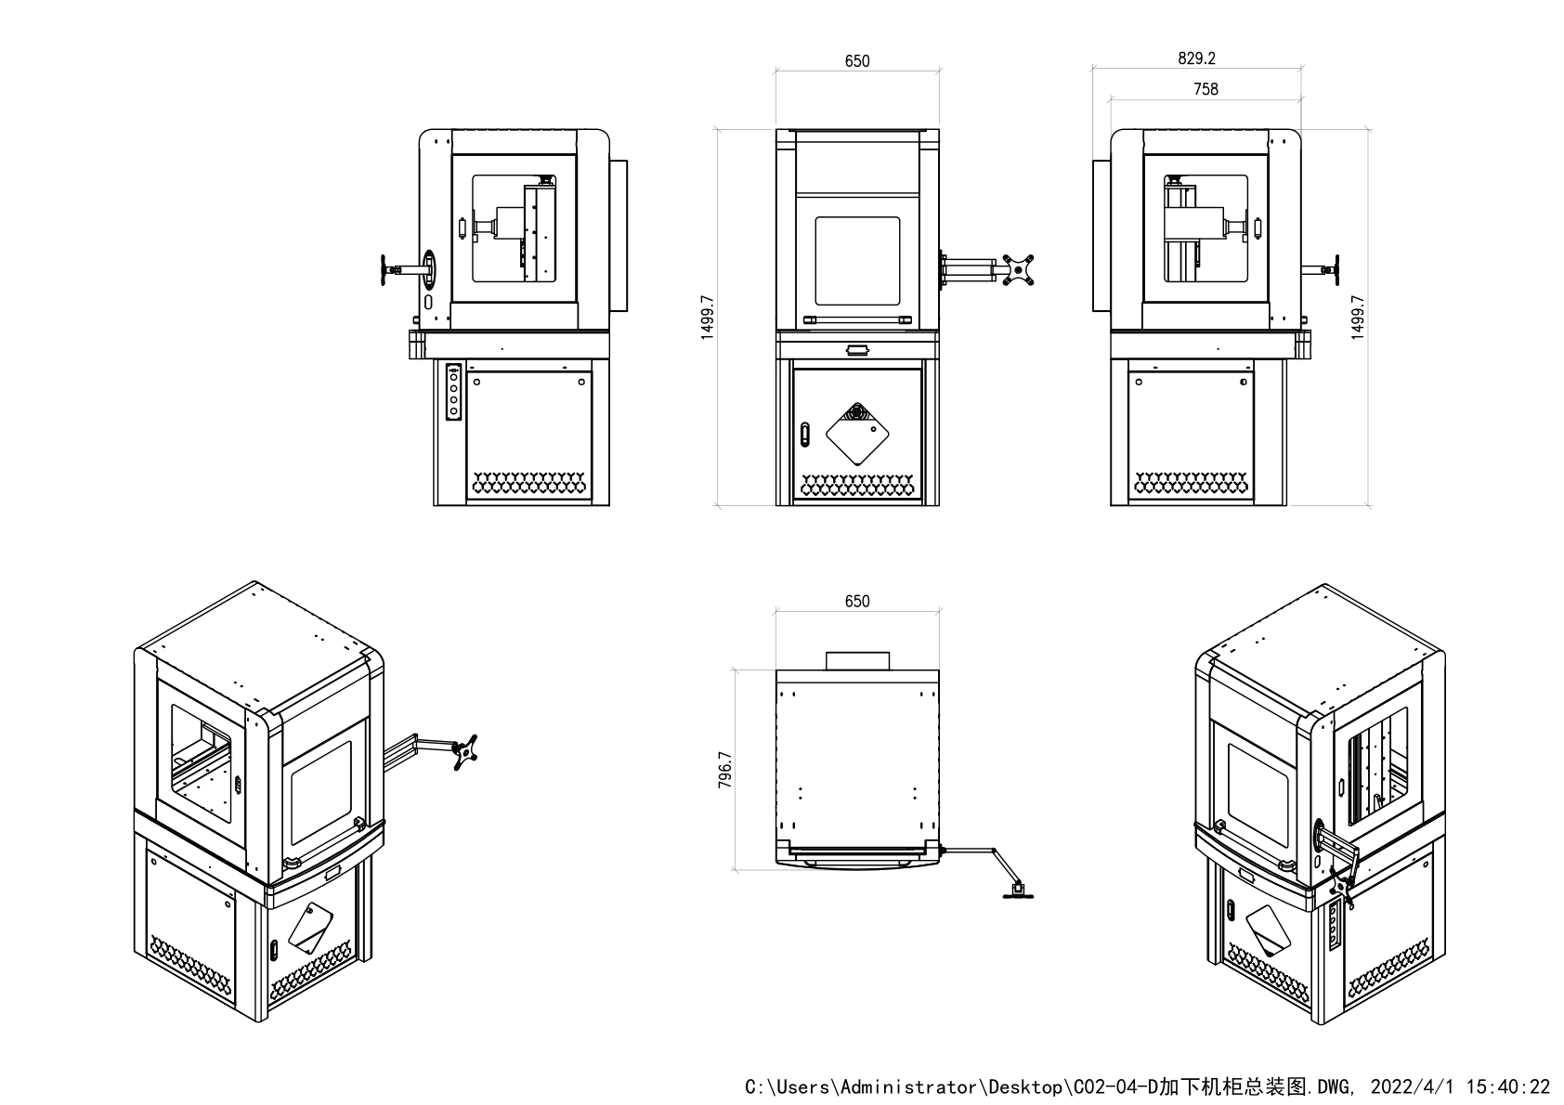

2.3 主要技术参数
Main Technical Parameters
参数名称 / Parameter | 规格 / Specification
激光类型 / Laser Type | 光纤激光器 / Fiber Laser
激光波长 / Wavelength | 1064 nm
输出功率 / Output Power | 20W / 30W / 50W（视型号而定 / Depending on model）
打标范围 / Marking Area | 110x110mm / 175x175mm / 300x300mm（可选 / Optional）
最小线宽 / Min. Line Width | 0.01 mm
重复精度 / Repeatability | +/-0.002 mm

第三章 开机与关机操作规程
Chapter 3 Power On/Off Procedures
3.1 开机顺序
Power-On Sequence
① 打开总电源（主电源开关）
① Turn on main power switch
② 启动电脑，等待系统完全启动
② Start the computer and wait for full system boot
③ 打开激光电源（钥匙开关）
③ Turn on laser power (key switch)
④ 启动打标程序（EzCad2 软件）
④ Launch marking software (EzCad2)
⑤ 确认软件与设备连接正常后，开始打标
⑤ Verify software-device connection, then begin marking

3.2 关机顺序
Power-Off Sequence
① 退出打标程序（EzCad2 软件）
① Exit marking software (EzCad2)
② 关闭激光电源（钥匙开关）
② Turn off laser power (key switch)
③ 关闭电脑系统
③ Shut down the computer system
④ 关闭总电源（主电源开关）
④ Turn off main power switch

注意 / Note
NOTE
关机后如需重新开机，请等待至少30秒后再开启总电源，以保护激光器。
After power-off, wait at least 30 seconds before turning the main power back on to protect the laser source.

第四章 设备日常保养
Chapter 4 Daily Equipment Maintenance
4.1 光学器件保养
Optical Components Maintenance
• 先用镜头纸沾酒精，把透镜镜1外表面清洗干净；
• First, use lens paper dipped in alcohol to clean the outer surface of Lens 1;
• 小心卸下透镜2和透镜3，并清洗透镜内表面；
• Carefully remove Lens 2 and Lens 3, and clean the inner surfaces;
• 最后用棉签沾酒精清洗X/Y反射镜。
• Finally, use a cotton swab dipped in alcohol to clean the X/Y reflection mirrors.
• 若发现聚焦镜头上有油脂，须取下镜头，用棉签蘸99.5%以上纯酒精擦洗。
• If grease is found on the focusing lens, remove it and clean with a cotton swab dipped in >=99.5% pure alcohol.
4.2 设备清洁
Equipment Cleaning
定期清理工作台和设备表面灰尘，保持设备外观及周围环境无杂物、无尘、洁净。
Regularly clean dust from the workbench and equipment surfaces. Keep the equipment exterior and surrounding area free of debris, dust, and contamination.
清洁设备时，禁止移动机器。
Do not move the machine during cleaning.
4.3 电脑主机和软件系统
Computer & Software System
• 定期清理电脑电源、CPU风扇灰尘，电路板上灰尘；
• Regularly clean dust from the computer power supply, CPU fan, and circuit boards;
• 定期对打标内容进行文件数据备份；
• Regularly back up marking file data;
• 定期进行病毒扫描，确保系统安全。
• Perform regular virus scans to ensure system security.
4.4 风冷系统保养
Cooling System Maintenance
保持风机系统周围进出风通畅，定期清理风机上面的灰尘，包括激光器散热风机和散热器。
Keep air intake and exhaust around the fan system unobstructed. Regularly clean dust from the fan, including the laser cooling fan and heat sink.
4.5 保养周期表
Maintenance Schedule
保养项目 / Item | 每日 / Daily | 每周 / Weekly | 每月 / Monthly
光学镜头清洁 / Lens cleaning | YES | YES | YES
工作台清洁 / Workbench cleaning | YES | YES
电脑灰尘清理 / PC dust cleaning |  | YES | YES
接地检查 / Grounding check |  |  | YES

第五章 EzCad2 软件操作说明
Chapter 5 EzCad2 Software Operation Guide
EzCad2 国际版是光纤激光打标机的专用控制软件，支持 Unicode，可运行于 Windows XP 及以上操作系统。
EzCad2 International Edition is the dedicated control software for fiber laser marking machines. It supports Unicode and runs on Windows XP and above.
如未正确安装加密狗，软件启动时会提示系统无法找到加密狗，将进入演示模式，演示模式下无法加工和存储文件。
If the security dongle is not correctly installed, the software will prompt "Cannot find dongle, entering demo mode", in which processing and file saving are disabled.
5.1 软件启动与界面介绍
Software Startup & Interface
• 双击桌面 EzCad2.exe 图标启动软件；
• Double-click the EzCad2.exe icon on the desktop to start the software;
• 正确安装加密狗后，软件正常进入主界面；
• With the dongle correctly installed, the software enters the main interface normally;
• 主界面包含：菜单栏、工具栏、绘制工具栏、对象列表栏、对象属性栏、工作区。
• The main interface includes: Menu Bar, Toolbar, Drawing Toolbar, Object List, Object Properties, and Work Area.
5.2 文件操作
File Operations
• 【新建】Ctrl+N：新建一个空白工作文件；
• [New] Ctrl+N: Create a new blank work file;
• 【打开】Ctrl+O：打开已保存的 .ezd 格式文件；
• [Open] Ctrl+O: Open an existing .ezd format file;
• 【保存】Ctrl+S：保存当前文件；
• [Save] Ctrl+S: Save the current file;
• 【另存为】将当前文件另存为新文件；
• [Save As] Save the current file as a new file;
• 支持导入 AI、DXF、DST、PLT 等矢量文件格式；
• Supports importing vector file formats such as AI, DXF, DST, PLT;
• 支持导入 BMP、JPG、GIF、PNG、TIF 等图像格式。
• Supports importing image formats such as BMP, JPG, GIF, PNG, TIF.
5.3 绘制与编辑
Drawing & Editing
• 绘制工具栏提供：点、曲线、矩形、圆、椭圆、多边形、文字、位图、矢量文件等；
• Drawing toolbar provides: Point, Curve, Rectangle, Circle, Ellipse, Polygon, Text, Bitmap, Vector File, etc.;
• 【文字】工具支持 TrueType 字体、单线字体（JSF）、圆弧文本、变量文本；
• [Text] tool supports TrueType fonts, single-line fonts (JSF), arc text, and variable text;
• 【填充】工具提供多种填充模式（网格填充、环形填充等），用于提高打标效率；
• [Hatch] tool provides multiple fill modes (grid hatch, ring hatch, etc.) to improve marking efficiency;
• 【阵列】功能支持矩形阵列和圆形阵列，快速复制多个相同图形；
• [Array] function supports rectangular and circular arrays for quick duplication;
• 【节点编辑】可对任意曲线进行节点级别的精细编辑。
• [Node Edit] enables fine-grained editing at the node level for any curve.
5.4 加工设置与运行
Processing Setup & Execution
• 【笔列表 / Pen List】：设置不同图层（笔）的打标参数，包括速度、功率、频率等；
• [Pen List]: Set marking parameters for different layers (pens), including speed, power, frequency, etc.;
• 【加工对话框 / Processing Dialog】：设置总体加工参数，预览加工路径；
• [Processing Dialog]: Set overall processing parameters and preview the processing path;
• 【开始标刻 / Start Marking】：启动激光打标加工；
• [Start Marking]: Start laser marking processing;
• 【暂停 / Pause】：暂停当前加工；
• [Pause]: Pause current processing;
• 【停止 / Stop】：停止当前加工。
• [Stop]: Stop current processing.
5.5 设备参数设置
Device Parameter Settings
• 【设备参数 / Device Parameters】：设置区域参数（打标范围、原点偏移等）；
• [Device Parameters]: Set area parameters (marking area, origin offset, etc.);
• 【激光参数 / Laser Parameters】：设置激光功率、频率、脉宽、开光延时等；
• [Laser Parameters]: Set laser power, frequency, pulse width, laser on delay, etc.;
• 【端口参数 / Port Parameters】：设置IO端口、输入口、输出口等；
• [Port Parameters]: Set IO ports, input ports, output ports, etc.;
• 【系统参数 / System Parameters】：设置软件语言、工作空间、自动备份等。
• [System Parameters]: Set software language, workspace, auto-backup, etc.

第六章 操作人员操作规程
Chapter 6 Operator Procedures
6.1 开机前检查
Pre-Operation Checks
操作人员需清洁设备外观和周围工作环境，做到无杂物、无尘、洁净，设备摆放整齐，无不相干物品；
The operator must clean the equipment exterior and surrounding work environment - no debris, no dust, clean and tidy, with no irrelevant items;
检查场镜盖子是否盖在镜头上面，若盖着必须取下，避免激光烧坏镜盖；
Check if the field lens cover is on the lens. If yes, remove it to prevent laser from burning the cover;
操作人员必须戴上防护手套；
The operator must wear protective gloves;
确认总电源电压稳定（AC220V+/-5%，50Hz），接地电阻<=0.5 ohm；
Confirm main power voltage is stable (AC220V+/-5%, 50Hz), grounding resistance <=0.5 ohm;
检查冷却风机运转正常，进出风通畅。
Check that the cooling fan operates normally and air flow is unobstructed.
6.2 运行中注意事项
In-Operation Precautions
打标时，操作人员的手不能触碰到光纤激光打标机的焦点（即激光和被加工件的接触点）；
During marking, the operator's hand must not touch the focal point of the fiber laser marking machine (i.e., the contact point between laser and workpiece);
不要去乱动主控机箱上面的按钮开关；
Do not tamper with the buttons and switches on the main control cabinet;
不要用手去触摸激光打标头，此时激光正在高功率运行中，温度极高，十分危险；
Do not touch the laser marking head with your hand - the laser is operating at high power and the temperature is extremely high, posing serious danger;
若发现聚焦镜头上有油脂，须取下镜头，用棉签蘸99.5%以上纯酒精擦洗，否则影响打标效果；
If grease is found on the focusing lens, remove the lens and clean with a cotton swab dipped in >=99.5% pure alcohol, otherwise marking quality will be affected;
打标过程中，严禁将头部或身体任何部位伸入打标区域内。
During marking, never extend the head or any body part into the marking area.
6.3 关机后操作
Post-Operation Procedure
关闭激光电源和软件后，清洁设备外观和周围工作环境；
After turning off laser power and software, clean the equipment exterior and surrounding work area;
检查光学镜头是否洁净，如有污染及时清洁；
Check whether optical lenses are clean; clean promptly if contaminated;
确认设备周围无易燃物品，关闭总电源；
Confirm no flammable items around the equipment, then turn off main power;
填写设备运行记录表，记录当日打标数量、异常情况等。
Fill in the equipment operation log, recording daily marking quantity, abnormal conditions, etc.

第七章 常见故障排除
Chapter 7 Troubleshooting
故障现象  Fault Phenomenon | 可能原因  Possible Cause | 处理方法  Solution
设备无法开机  Machine cannot power on | 检查总电源是否接通；检查急停按钮是否复位；检查保险丝是否熔断 | Check main power connection; Check emergency stop button is released; Check if fuse is blown
软件启动时提示找不到加密狗  Dongle not found on startup | 检查加密狗是否正确插入USB口；尝试更换USB接口；重新安装加密狗驱动 | Check dongle is properly inserted into USB port; Try a different USB port; Reinstall dongle driver
激光不出光  Laser does not fire | 检查激光电源是否打开；检查钥匙开关位置；检查EzCad2中激光参数设置；检查冷却系统是否正常 | Check laser power is on; Check key switch position; Check laser parameter settings in EzCad2; Check cooling system
打标效果不清晰或不均匀  Marking quality unclear or uneven | 检查聚焦镜头是否清洁；检查焦距是否正确；检查打标参数（速度/功率/频率）是否合理；检查工件表面是否平整 | Check focusing lens is clean; Check focus distance is correct; Check marking parameters (speed/power/frequency); Check if workpiece surface is flat
振镜不动作或打标位置偏移  Galvanometer not moving or position shift | 检查振镜电源是否接通；检查EzCad2中设备参数设置（区域参数/原点偏移）；重新校准打标范围 | Check galvanometer power; Check device parameter settings in EzCad2 (area params/origin offset); Re-calibrate marking area
电脑运行中频繁死机  Computer frequently freezes | 检查CPU风扇是否正常；检查内存是否充足；检查是否有病毒；检查电网电压是否稳定 | Check CPU fan; Check memory sufficiency; Check for viruses; Check grid voltage stability

第八章 联系方式
Chapter 8 Contact Information
如本操作说明书有任何疑问，或设备出现无法排除的故障，请联系：
If you have any questions about this manual, or if the equipment experiences troubleshooting beyond your ability, please contact:

公司名称 / Company | 东莞市拓取智能装备有限公司  Dongguan Tuoqu Intelligent Equipment Co., Ltd.
服务热线 / Service Hotline | +86-769-82581066
技术支持 / Technical Support | tuoqu@tokyucn.com
公司地址 / Address | (Please fill in company address / 请填写公司地址）

—— 本操作说明书完 ——
--- End of Operation Manual ---

